Potato Spirals in Air Fryer

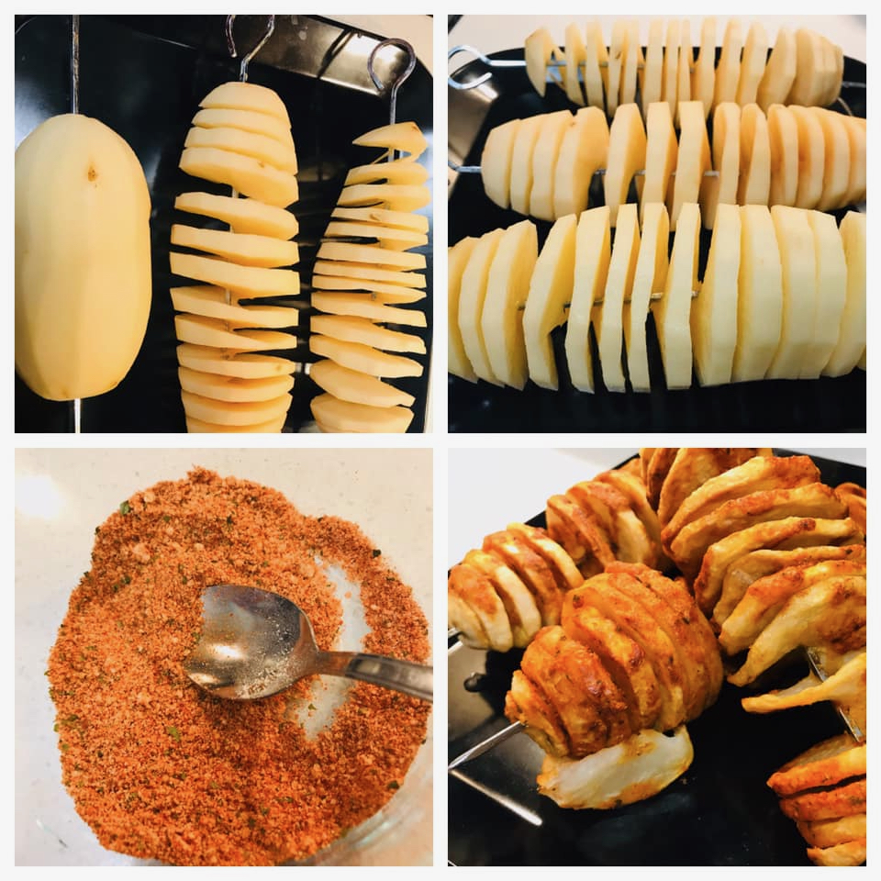

Ingredients

* Potatoes 3
* Paprika ½ tsp
* Parmesan cheese grated ¼ cup
* Garlic powder ¼ tsp
* Dried parsley ¼ tsp
* Black pepper powder ½ tsp
* Salt as required

Method

In a small bowl mix all the ingredients except potatoes. Peel skin of the potatoes wash and pat dry. Push the skewer through the center of the potato from one end to the other. Run the knife in spirals to slice the potato.

Preheat the air fryer to 380 deg F for 15 minutes. Grease the air fryer tray with olive oil cooking spray. Place the potato skewers in the air fryer. Spray olive oil cooking spray on the potatoes. Close the air fryer and let it run. Halfway through, remove the skewers and sprinkle the spice mix on top of and in between the potatoes. Place it back in the air fryer and continue till the potatoes begin to brown and are crispy. Check and adjust fryer timings and take care not to burn the potatoes.